**Cedefop presents CrowdLearn study, offering a glimpse into future work and learning**

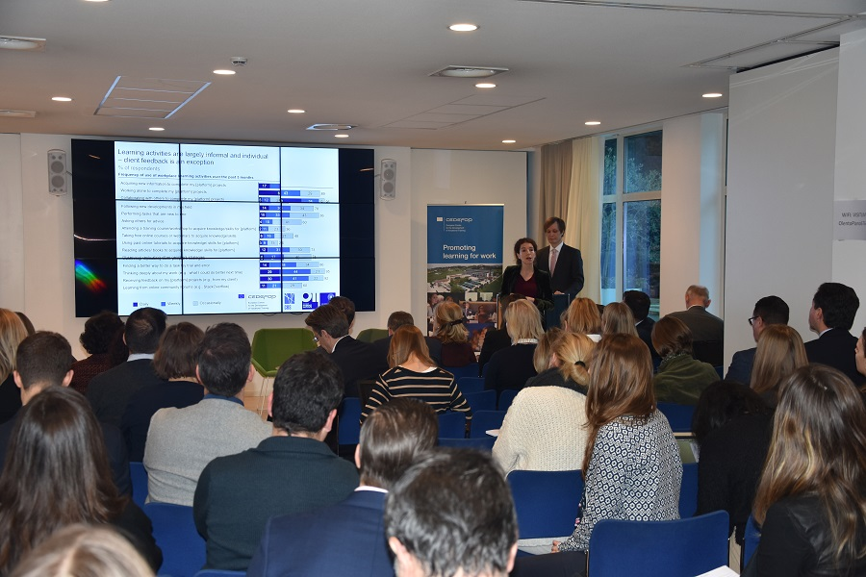

**Image copyright:**

© Cedefop, 2019/Cosmin Roman

**Cedefop presented the main results of its CrowdLearn study ‘*Skills formation and skill matching in online platform work*’ to European policy-makers at its**[**8th Brussels seminar**](https://www.cedefop.europa.eu/en/events-and-projects/events/skill-development-workers-platform-economy-anticipating-future-work-and-learning)**on 10 December.**

Organised in cooperation with the rotating EU Presidencies, this time with the Finnish Presidency, Cedefop’s Brussels seminars build on Cedefop research and analyses, and address issues relevant to European debates on vocational education and training (VET) and employment.

The 8th seminar, a [**European vocational skills week event**](https://www.cedefop.europa.eu/en/tags/european-vocational-skills-week), focused on the implications of new forms of work due to digitalisation, especially rising online platform work, for workers’ skills formation and matching. Cedefop expert Konstantinos Pouliakas, who designed the CrowdLearn study, argued: ‘This is a flagship research product of Cedefop’s ‘***[Digitalisation, AI and future of work](https://www.cedefop.europa.eu/en/events-and-projects/projects/digitalisation-and-future-work)***’ project; it is the first ever study to focus on the skill formation and matching practices of online freelancers offering labour services in the online platform or ‘gig’ economy. Based on in-depth interviews with platform owners, crowdworkers and policy stakeholders, as well as analysis of a large-scale new database of 1 000 crowdworkers, the study enables us to construct a unique typology of the skills most often developed in crowdwork, understand their learning practices, identify skill gaps and demarcate the challenges associated with new forms of algorithmic skills matching that takes place in the online platform economy.’

**Education or ignorance**

Representing the Finnish EU Presidency, Johanna Koponen emphasised the value of lifelong learning for citizens and of building a strong capacity for anticipating new and emerging skill demands. ‘If you think education and training are expensive, try ignorance,’ she concluded.

Cedefop Deputy Director Mara Brugia also reflected on the key challenge that automation poses for EU labour markets, specifically the expected job transformation: 'Artificial intelligence and automation do not necessarily destroy jobs, but reshape them and create new ones. Jobs demanding worker autonomy, planning, teamwork and customer-service skills are expected to resist automation better. This requires new skills and occupational profiles to complement them, like data analytics. The move to a low-carbon economy will also see new or growing green occupations, but mainly green skills across the board, as Cedefop’s analysis points out.'

As revealed by a study using Cedefop’s [**European skills and jobs survey**](https://www.cedefop.europa.eu/el/events-and-projects/projects/european-skills-and-jobs-esj-survey) data, while [**only 14% of EU jobs face a very high risk of being completely automated**](https://www.cedefop.europa.eu/files/automation_risk_in_the_eu_labour_market.pdf), close to 4 in 10 EU jobs may see some transformation in the tasks and skills required, highlighting the need for EU workers to reskill and upskill.

Oxford University Internet Institute Professor Vili Lehdonvirta and Copenhagen Business School Professor Anoush Margaryn, who carried out the CrowdLearn study research for Cedefop, presented some of its key findings. They highlighted that a unique blend of entrepreneurial, self-branding, communication and organisational skills as well as focused personal dispositions are found to be a particularly important prerequisite for success in online platform markets. They stressed several examples of platforms increasingly assuming a training provider role, although crowdworkers often see little value in such efforts or in other conventional vocational courses; by contrast they rely more often on just-in-time or bite-sized online courses.

The study also highlighted that skills matching in this new digital marketplace tends to take place via algorithmic management. Workers’ reputation scores acquired by clients generally tend to prevail over more conventional forms of signalling their skills, such as qualifications, microcredentials or skill tests.

European Commission Joint Research Centre’s Annarosa Pesole presented key insights of the 2nd wave of the COLLEEM survey, the EU’s dedicated survey measuring the incidence of platform work and the tasks and working conditions characterising platform workers.

**Recommendations**

A debate with the audience on policies that could facilitate crowdworkers’ continuing training and cost-sharing of skills investments was coordinated by Cedefop expert Jiri Branka. He showcased the Cedefop study’s 11 policy recommendations, which target issues related to the labour market inclusion of new crowdworkers, their initial and continuing professional development and improvement in transparency of their skills matching. A main recommendation is the suggestion for policy-makers to collaborate with platforms in experimenting with a system of subsidised micro-internships to counteract barriers to newcomers into online platform markets due to deficient client feedback scores.

The study's final report will be published in the first half of 2020.